- Go to westsurreycatenians.org website and click Log In/Sign Up shown by 1 below.
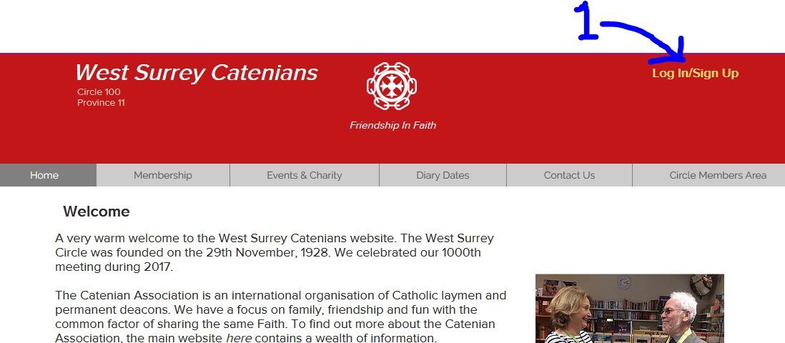
- On the Log In screen, click “Sign Up” indicated by 2 below.
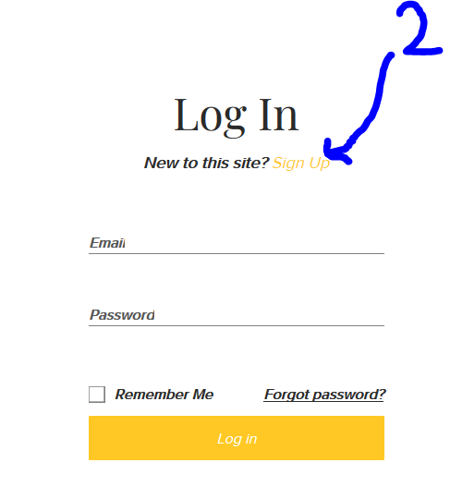
- After clicking 2 above, the Sign Up screen below will be displayed. Enter your email address at 3, then enter the password that you would like at 4 (note you won’t be able to see the password you are entering as each character will be masked by a dot), then click button 5.
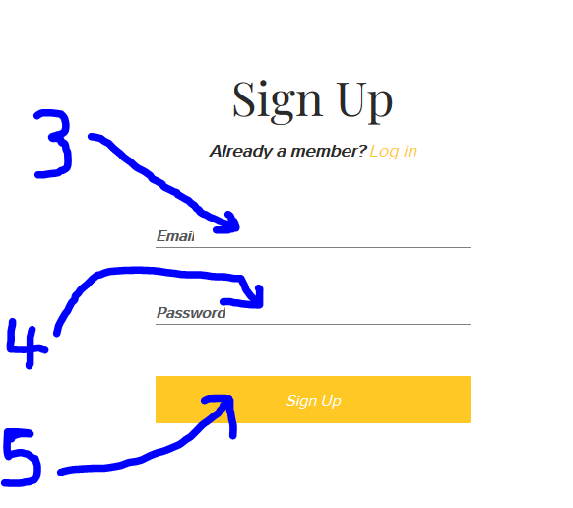

- The screen below will be displayed next. This confirms your request has been sent to me for approval. Click 6 which will take you back to the website.
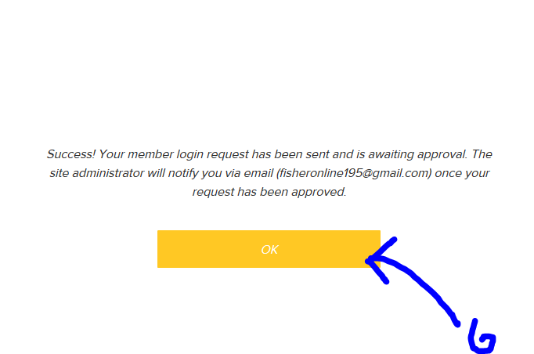
- What now happens is that I receive an email; I check that I recognise the email address as someone in the Circle and I approve it. I will only approve people with email addresses that I recognise. When I approve it, you will get an email from W. Surrey Catenians like the one below. Click on the button “Go to Site” indicated at 7 in the picture or just go back to our website westsurreycatenians.org.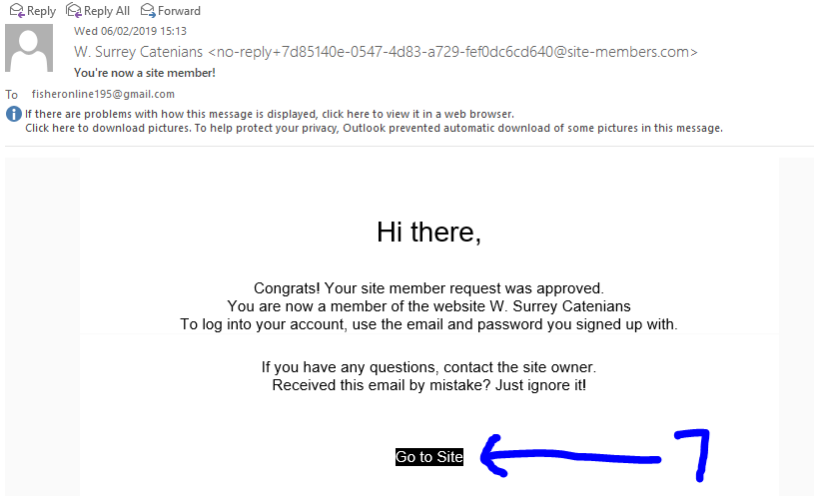
- Click on the Log In/Sign Up link as show at 8 in the diagram below.
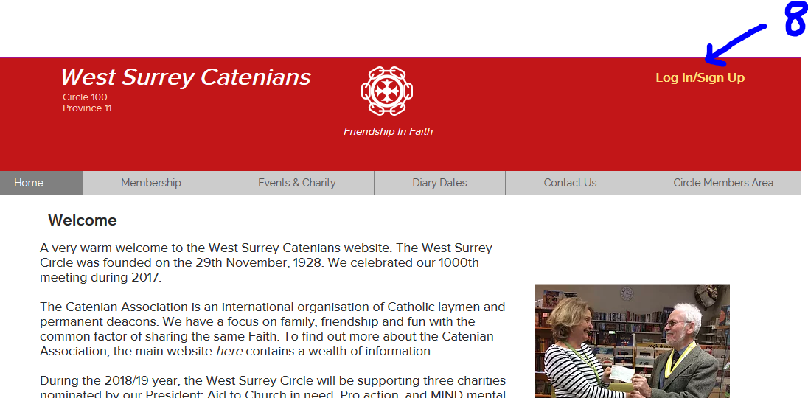
- Fill in your email address (9) and password (10) that you used in step 3. Click on the “Remember Me” box (11) and then click on Log In (12).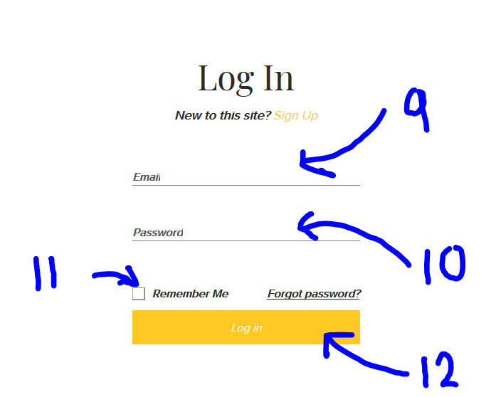
- That’s it! You should now be logged-in and see the first part of your email address (13). You should now be able to get to the pages in the circle members area.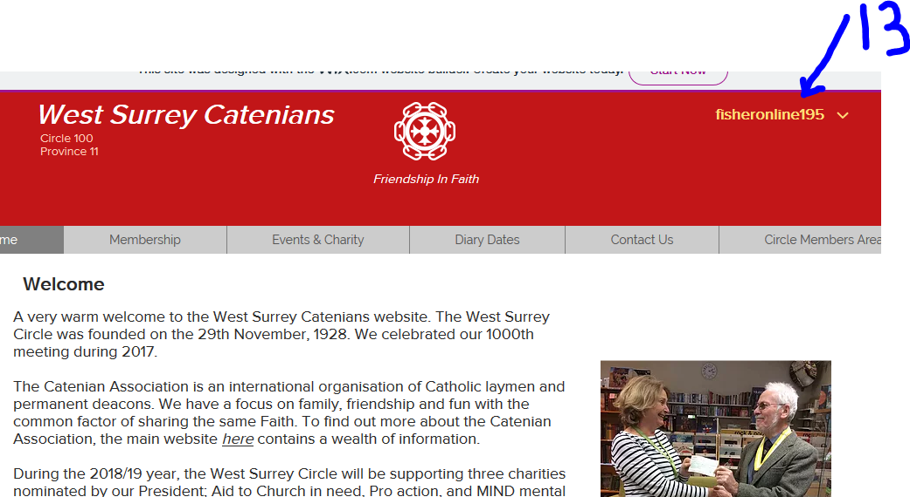
- Finally if you should ever forget your password, just click on the “Forgot Password” link on the Log In page – you will then be able to reset it. NB I do not have any access or am able to see users passwords as they are encrypted.

